1770Poem

‘Lovely Betty's Reply; or Her kind Invitation to welcome her Boy Home again.’

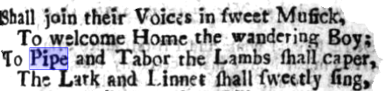

Lovely Betty's garland. Beautified with several excellent new songs.

https://archive.org/details/bim_eighteenth-century_lovely-bettys-garland-_1770/page/4/mode/2up?q=%22pipe-and-tabor%22

