1782Poem

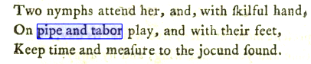

Henry, or, The wanderer reclaimed : a sacred poem humbly addressed to British youth
by
De Fleury, Maria, 1773-1791

https://archive.org/details/henryorwandererr00defliala/page/12/mode/2up?q=%22pipe-and-tabor%22

