1784Song

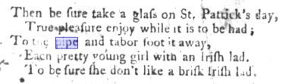

‘The Irish Lad.’ Sung by Mrs. Wrighten, in the new comic opera called The Double Disguise. 1784
by
Hook, Mrs. (James)

https://archive.org/details/bim_eighteenth-century_the-irish-lad-sung-by-m_hook-mrs-james_1784/mode/1up?q=%22pipe-and-tabor%22

