1440to70GamesBox

Southern Netherlandish, circa 1440-1470
Games Box with Court Scenes

Box side
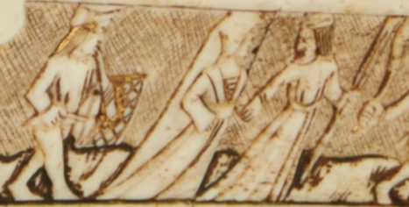

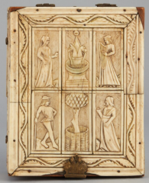
Box top
https://www.sothebys.com/en/buy/auction/2022/master-sculpture-works-of-art-part-ii/games-box-with-court-scenes

